**Blue nitrogen burial can boom or bust in future tidal wetlands**

|  |  |  |
| --- | --- | --- |
| **Name** | **Affiliation** | **email** |
| J. Adam Langley | Dept. of Biology, Center for Biodiversity and Ecosystem Stewardship, Villanova University | adam.langley@villanova.edu |
| Samantha K. Chapman | Dept. of Biology, Center for Biodiversity and Ecosystem Stewardship, Villanova University | samantha.chapman@villanova.edu |
| Tania L. Maxwell | Biodiversity and Natural Resources Program, International Institute for Applied Systems Analysis, 2361 Laxenburg, Austria 2. Conservation Science Group, Department of Zoology, University of Cambridge, Cambridge, UK | [taniamaxwell7@gmail.com](mailto:taniamaxwell7@gmail.com) |
| Lisa Chambers | Dept. of Biology, University of Central Florida, Orlando, FL 32816 | Lisa.chambers@ucf.edu |
| Josh L. Breithaupt | Florida State University, Coastal & Marine Laboratory | jbreithaupt@fsu.edu |
| Steven W. J. Canty | Smithsonian Environmental Research Center, Edgewater, MD 21307 | [cantys@si.edu](mailto:cantys@si.edu) (ORCiD 0000-0001-9927-7736) |
| Matthew L. Kirwan | Virginia Institute of Marine Science, William & Mary | kirwan@vims.edu |
| Christopher Craft | O’Neill School of Public and Environmental Affairs, Indiana University | ccraft@indiana.edu |
| Ken W. Krauss | U.S. Geological Survey, Wetland and Aquatic Research Center | [kraussk@usgs.gov](mailto:kraussk@usgs.gov) |
| Andre S. Rovai | 1U.S. Army Engineer Research and Development Center, Vicksburg, MS 39180  2Department of Oceanography and Coastal Sciences, Louisiana State University, Baton Rouge, LA 70803 | [andre.s.rovai@usace.army.mil](mailto:andre.s.rovai@usace.army.mil) |
| Catherine E. Lovelock | School of Environment, The University of Queensland, St Lucia QLD 4072, Australia | [c.lovelock@uq.edu.au](mailto:c.lovelock@uq.edu.au) |
| Ana Carolina Ruiz-Fernández | Unidad Académica Mazatlán. Instituto de Ciencias del Mar y Limnología. Universidad Nacional Autónoma de México | caro@ola.icmyl.unam.mx |
| Amanda C Spivak | University of Georgia, Marine Sciences Department, Athens, GA 30602 | [aspivak@uga.edu](mailto:aspivak@uga.edu)  0000-0001-6743-0783 |
|  |  |  |
|  |  |  |

**Abstract**

Coastal wetlands sequester inordinate masses of nitrogen (N) with implications for global N cycling and estuarine water quality, yet the magnitude of current uptake and the strength of future N sinks remain uncertain. Our goal was to estimate tidal wetland contribution to global rates of N burial and determine how those rates may change in the future. We assembled a database of tidal wetland soil [N] and found that C:N stoichiometry differed sharply between marshes and mangroves but remained remarkably consistent within each habitat type. We used these relationships to leverage extensive knowledge of carbon (C) stocks and accumulation rates to estimate that coastal wetlands bury 2.7 Tg N yr-1, accounting for up to one-third of global N burial. The rate of N sequestration will rise if wetlands build soil vertically to better pace accelerating sea level rise, or are restored on a large scale. However, we estimate that coastal wetland soils contain roughly 403 Tg N to 1 m depth, and some fraction of that will be released from collapsing wetlands, exacerbating coastal pollution. We posit that the consequences of changes in blue N for ecosystem functioning rival those of blue C.

**Introduction**

Recent eutrophication crises such as persistent red tides along the Florida Gulf coast and the extensive sargassum bloom in the tropical Atlantic are linked to escalating nutrient runoff from land (Brewton et al., 2022; M. Wang et al., 2019). Despite large increases in anthropogenic reactive N production over the last century (Gruber & Galloway, 2008), N availability may be declining in many terrestrial ecosystems owing to other anthropogenic forces such as climate change and rising atmospheric CO2, potentially reducing N runoff in some regions (Mason et al., 2022). Terrestrial nutrient loads commonly pass through estuaries where tidally flushed coastal wetlands can mitigate estuarine and oceanic pollution by transforming N to gaseous forms or by sequestering N in biomass or in soils for millennia or longer. However, coastal wetland collapse and erosion can release formerly inert nutrients into surrounding waters where some fraction will be recirculated (Cornwell et al., 2022; Lane et al., 2016; Sapkota & White, 2021). Despite the importance of N in ecosystem function the role of tidal wetland N burial in the global N cycle has yet to be explicitly constrained.

While wetlands have long been appreciated as hotspots of nutrient transformation (Odum, 1980; Valiela & Teal, 1979, Twilley 1988), their role in long-term sequestration in organic matter has not been explicitly assessed in global N budgets. Inferred estimates of global N burial in the coastal zone range from 8-25 Tg N year-1, but it is frequently unclear if these values include coastal wetland sequestration (Gruber & Galloway, 2008; Voss et al., 2013). For instance, one ultimate source of these estimates mentions only “deltaic sediments” as a sink, which could include coastal wetlands but also nearshore underwater sediments (Hedges & Keil, 1995). Wetlands experiencing high rates of relative sea level rise (RSLR) increase rates of marsh and mangrove surface elevation gain and concomitantly gain soil C more rapidly (Morris et al., 2002; Rogers et al., 2019) and will likely gain N more rapidly.

Recent efforts to value the C sink capacity of tidal wetlands as natural “blue C” solutions have led to increasing demand for tidal wetland restoration projects around the world (Lovelock et al., 2023; Macreadie et al., 2021; Tang et al., 2018). Blue C syntheses have quantified the C stocks in mangrove and marsh biomass and recent syntheses have estimated soil C sequestration potential (Atwood et al., 2017; Breithaupt & Steinmuller, 2022; Hinson et al., 2019; Ouyang & Lee, 2020; Rovai et al., 2018; Spivak et al., 2019). Studies on C density and flux in wetlands outnumber those on N by several-fold because of growing scientific and economic interest in blue C and perhaps because relatively simple methods such as soil loss-on-ignition can be reliably converted into C concentrations (Breithaupt et al., 2023). Blue N is a co-benefit to wetland conservation and restoration that has been overlooked (ref.. ).. We reason that if soil [N] is predictable by commonly measured parameters, then we can leverage the extensive knowledge about current and future C burial in wetlands to estimate the current extent and future capacity for the critical co-benefit of N storage.

Our primary goal was to find the best predictors of soil [N] so that we can assess N stocks and accumulation in coastal wetlands. First, we established a predictive relationship between soil [C] and soil [N] because a great deal more C data exist than N. We assembled a C:N database of coastal wetland soil profiles including 6,131131 samples from 731 cores in which segments were analyzed for C and N composition to establish the stoichiometry of soil and to determine what factors best predict wetland soil [N] considering readily assessable parameters such as habitat type, geomorphic setting, latitude, soil depth, and bulk density. Then, we used these relationships predicting C:N ratios to extrapolate from extensive existing databases of soil C accumulation rates to estimate N accumulation rates worldwide (F. Wang et al., 2021). Finally, we extrapolated the future potential for global N accumulation in, or release from, tidal wetland soils based on previously published projections for coastal wetland soil elevation and change in areal extent according to future social and ecological scenarios (citations?).?).

**Results and Discussion**

*Prediction of soil [N]*

The relationship between soil [C] and [N] ratio was extremely consistent within habitat types (r2 = 0.91), but differed sharply between marshes (C:N= 15) and mangroves (C:N= 21, Fig. 1). In soils with low bulk density, mangroves tended to have higher C:N ratio than marshes (Fig. S3) driving the divergence in high-C soils (Fig. 1). Soils with lower bulk density have higher organic matter concentrations as well as C content, and may reflect a generally greater plant influence. The difference in C:N may reflect the influence of woody structures which are produced by mangroves and have much higher C:N than other plant tissues and soils. Even though soil [C] and [N] vary sharply with depth in most studies, C:N ratio did not vary consistently with depth within or across studies (Table SX). Differences in coring depths and in the depth intervals sampled contribute negligible variation to soil C:N. Therefore, having ample soil C data from around the world will afford accurate prediction of soil N stocks and accumulation rates.

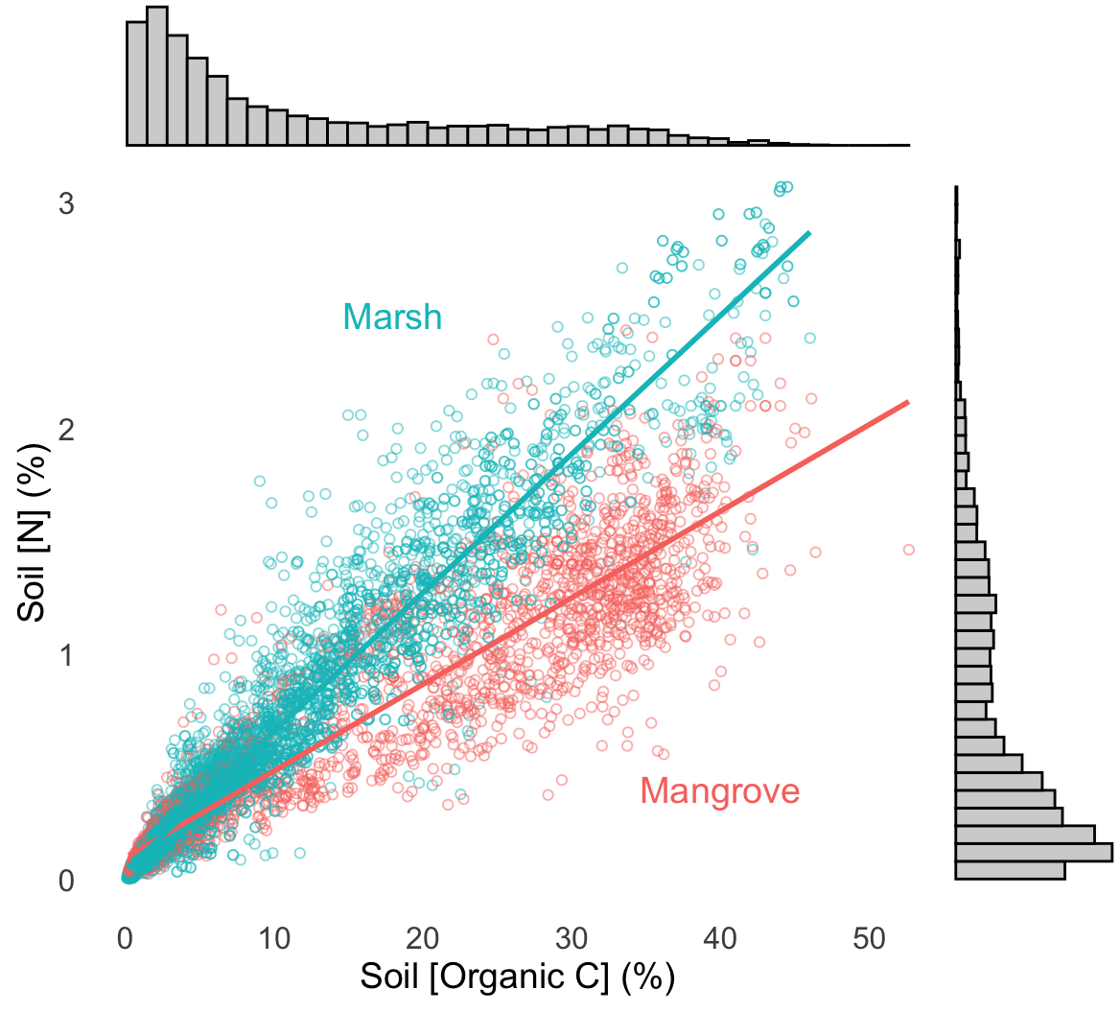

**Fig. 1**. The relationship between soil [N] and soil [C] from all depth increments across 14 coastal wetlands spanning from 0.1 to 44.3% C. Mangrove soil [N] = 0.0383 [C] + 0.101; marsh soil [N] = 0.0603 [C] + 0.0593.

*N accumulation rate*

The consistently tight relationship between C and N composition afforded high confidence in extrapolating from existing C accumulation estimates to N accumulation estimates across geographically and geomorphically diverse ecosystems. Using a synthesis of C accumulation based on 630 radiometrically dated cores across 102 sites representing broad geographical gradients (F. Wang et al., 2021), we found that the average N accumulation rate is 10.2 (± X.X) g N m-2 yr-1 (Fig. 2). Regional average estimates from tidal marshes N accumulation in the United States range from 3-19 g N m-2 yr-1 (Craft, 2007). Scaling to the area of marsh and mangroves (refTable 1ref, and ref, respectively) the dataset represents, this areal rate yields a total burial rate of 2.7 Tg N yr -1 globally. The amount of N sequestered in tidal wetlands contributes from 12-33% of global burial of N in all ecosystems (ref),), depending on the baseline of comparison. As with blue C, the sequestration rate of N depends strongly on the soil accumulation rate, which is largely determined by the rate of sea level rise. How the N burial rate may change in the future depends on the fate of coastal wetland extent and how much accommodation space is afforded by generally increasing rates of Rrelative SLRRSLR (Rogers et al., 2019).



**Fig. 3**. The distribution of coastal wetland N sinks across continents and global totals.

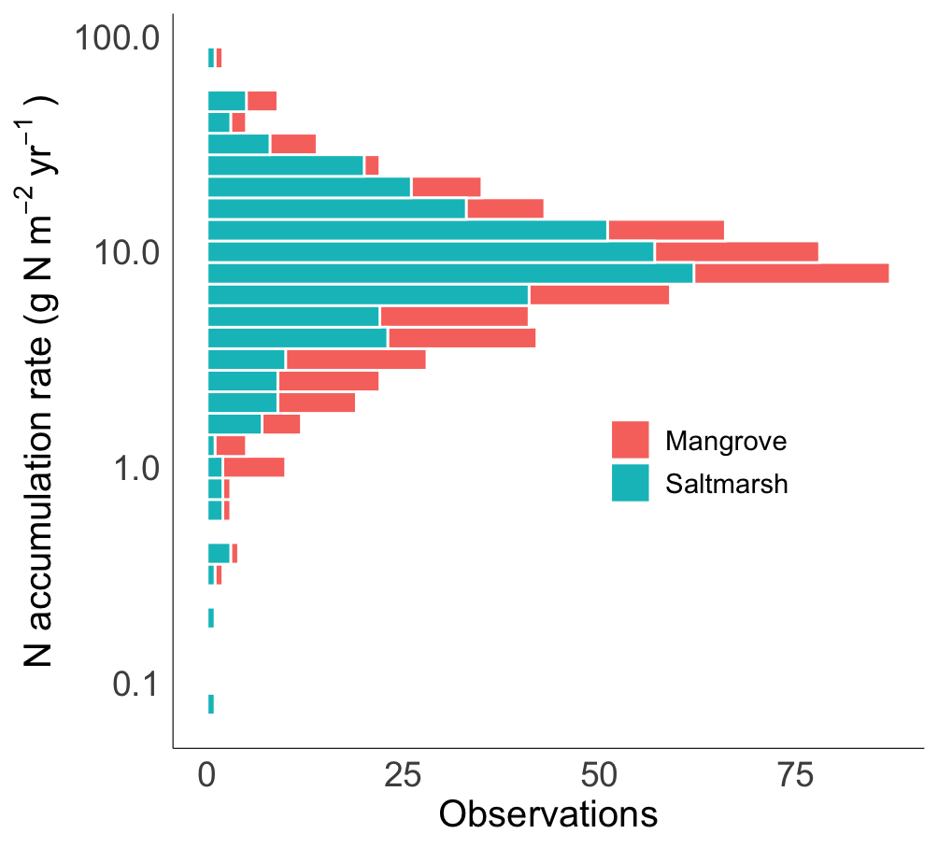

**Fig. 2**. Histogram of area-based estimates of N accumulation.

Median 8.2; mean=10.6 g N m-2 yr-1.

*Future scenarios*

As rates of sea level rise accelerate, the outcomes for nutrient mitigation become more extreme. If coastal wetlands are able to pace rising seas, as some scientist project, then the rate of N sequestration will increase nearly in proportion, as estimated for C accumulation (Schuerch et al., 2018). However, if accelerating sea level rise, or other anthropogenic forces, result in losses of wetland land area, then the buried N could recirculate in the environment (Lane et al., 2016). Though the fate of that N as it is eroded from wetlands to the ocean is not well constrained, some N could contribute further to exacerbating coastal eutrophication or to increasing emission of greenhouse gases like nitrous oxide. Most tidal wetland area has kept pace with the acceleration of sea level rise we have observed over the past 50 years (roughly from 1.5 mm yr-1 to 3.5 mm yr-1, UC boulder). Accordingly, the amount of N wetlands buried has likely increased with increasing accretion. Historical reconstructions have shown that marshes and mangroves likely have a break point between 5 and 10 mm yr-1, beyond which they can no longer pace SLR in such a way to persist, though these estimate depend on geomorphology and starting elevation (Saintilan et al., 2022). The N burial rate will likely continue to increase if wetland area is maintained or gained, but if ongoing rates of wetland loss accelerate N release could counteract N burial.

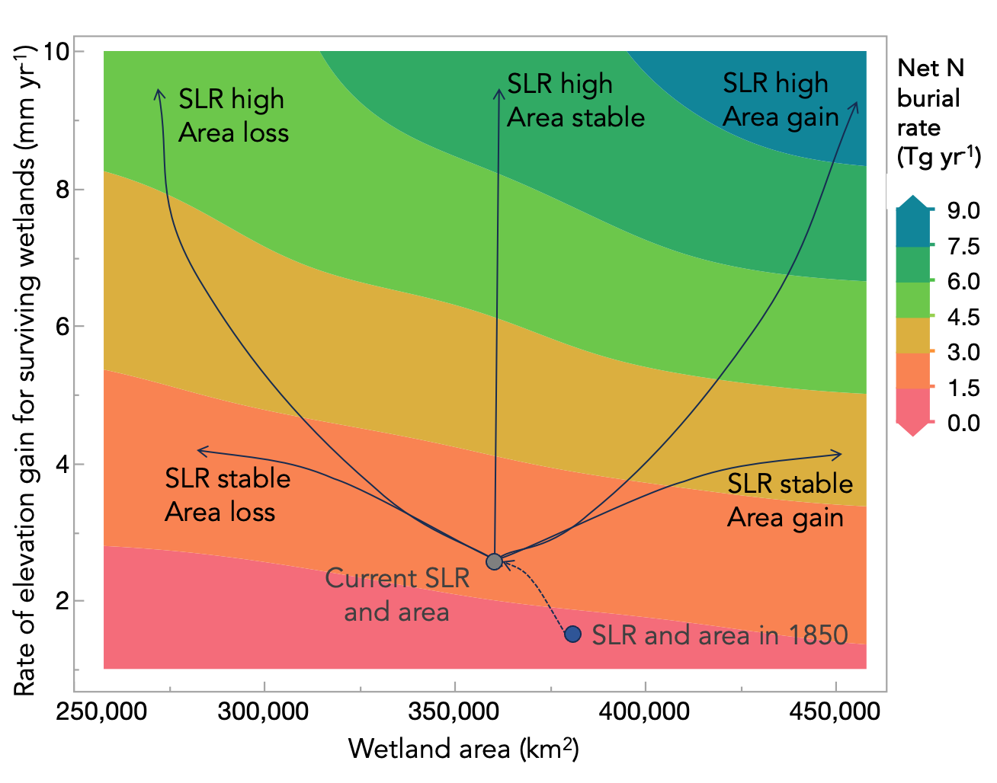

**Fig. 4.** Hypothetical plot of past and future scenarios of N burial in coastal wetlands. Colors represent global rate of N burial as it varies with rate of elevation gain of surviving wetlands and with gains or losses in wetland area through natural processes or human activity. Five future scenarios are plotted depending on the combination of coastal wetland area change and elevation gain rates of existing wetlands.

Increasing RSLR has been linked not only to higher rates of soil accumulation, but also to higher proportions of C in accumulating soil (Rogers et al., 2019). We might expect that increasing rates of RSLR could increase the [N] of accumulating soil as well, though our simple model did not assume this.

Blue C sequestration in tidal wetlands has been thoroughly accounted, but blue N may hold at least as much importance in the global N cycle. A number of syntheses have converged on a value of ~50 Tg yr-1 of C that is sequestered across all coastal wetlands, representing 0.5% of the current anthropogenic C emission rate. Given the C:N ratios of accumulating marsh soils, we estimate 2.7 Tg N yr-1 is buried in tidal wetlands every year. The sum of human contribution to the N cycle through industrial fixation, agricultural fixation, and fossil fuel combustion is estimated to be 150 Tg N yr-1 eclipsing natural sources (Schlesinger, 2009). Thus, if our estimates hold (that is, 2.7 Tg N yr-1) blue N burial would be equivalent to about 2% of human contributions. But a crucial difference between blue N and blue C is that, whereas C diffuses rapidly through the atmosphere to influence the entire globe, estuarine N pollution can have immediate and intense local effects. For instance, the rivers that discharge into the Atlantic coast of North America, deliver about 1 Tg of N annually to the estuaries (ref),), an amount that is exceeded by the demand of tidal wetland sequestration in the region.

*Sources and fates of buried N*

Wetland N burial could represent a strong force for drawing down N availability in surrounding coastal waters, but tidal wetlands also receive N inputs from N-fixation, groundwater delivery or atmospheric deposition (Tobias & Neubauer, 2019). In mangroves it was estimated that N-fixation only accounts up to 3.2 g N m-2 yr-1 and is often matched by denitrification rates in mangroves (Twilley & Rivera-Monroy, 2009), so that net gaseous exchange of N between wetlands and atmosphere is often considerably lower than total demand. In young marshes, rates of soil N burial greater than 35 g N m-2 yr-1 have been reported, which exceeds plant and soil demand (Currin et al., 1996). Though we have sharpened the estimates of total N burial, the partitioning of N sources to meet this demand remains highly uncertain. Regardless of its source, once N enters the soil organic N pool, it may remain nearly inert for millennia. Or, if the wetland soil is disturbed or the wetland collapses, soil N will be released abruptly into surrounding waters, however, its ultimate fate remains highly uncertain (Cornwell et al., 2022). We applied the same C:N relationships from above to estimates of C mass in wetlands to estimate that the global mass of N in tidal wetland soils is roughly 400 Tg N to 1 m depth (Table 1). Even if only a fraction of this large pool is eroded and only a fraction of that is remineralized, it could represent a locally significant contribution to coastal N budgets.

**Table 1**. Estimates of soil N mass stored in tidal wetlands.

|  |  |  |  |
| --- | --- | --- | --- |
|  | Area (km2) | N stock  (Mg ha-1) | Global N stock (Tg) |
| Marsh | 90,800 | 17 | 154 |
| Mangrove | 135,000 | 18 | 248 |
| Marsh+Mangrove | 225,800 | 35 | 403 |

*N-limitation of soil gain*

The demand for N by a wetland in equilibrium with sea level will scale with the rate of sea level rise. As sea level accelerates, the N demand by coastal wetlands will increase in step. We estimate, based on well understood stoichiometry of nutrient sinks in wetlands and rates of C accumulation, that in less polluted areas, nutrient scarcity could limit the potential for wetland elevation gain, particularly where rates of relative sea level rise are high. Regardless of the mechanisms by which the N is sourced and stabilized, there may be strict stoichiometric constraints on the upper end of wetland elevation gain.

**Supplement**

**Tables**

S1. Supplementary table of future scenarios and citations to support Fig. 4

**Figures**

S1. Map of soil C, N profiles sites

S2. [N] prediction model,

S3. Violin plots of C:N ratio by bulk density class.

**Table S1.** Data sources.

|  |  |  |
| --- | --- | --- |
| **Data source** | **Purpose** | **Key parameters** |
| Tidal wetland C:N (this study, Maxwell et al. 2023, Holmquist et al. 2024, Rovai et al. 2018) | Establish predictive relationships for soil [N] | Soil [C], [N], bulk density, habitat type, 731 cores from 18 studies |
| Carbon accumulation rate (F. Wang et al., 2021) | Allow for estimation of N accumulation from C accumulation rates determined from radiometric dating across a wide geographical range | C accumulation rate, 613 cores from 102 studies |
| Global wetland area (Mcowen et al., 2017; Spencer et al., 2016) | Extrapolate from site-specific rates to global rates of N accumulation. | Global marsh and mangrove area |
| (Campbell et al., 2022; Murray et al., 2022) | Infer past exchange of tidal wetland N | Estimates of coastal wetland loss and gain |
| (Macreadie et al., 2021; Saintilan et al., 2022, 2023) | Generate realistic future scenarios for tidal wetland elevation gain and wetland area gain or loss through erosion, deposition, development or restoration. | Area change, elevation gain. |

**Fig. S1. Map of cores included in C:N database.**





**Fig. S2**. The best prediction model for coastal wetland soil [N].

Mangrove %N = a + b (%C) -0.11323 + (%C – 11.56244) * -0.01085

Marsh %N = a + b (%C) +0.11323 + (%C – 11.56244) * 0.01085

R2 = 0.88, N=6185

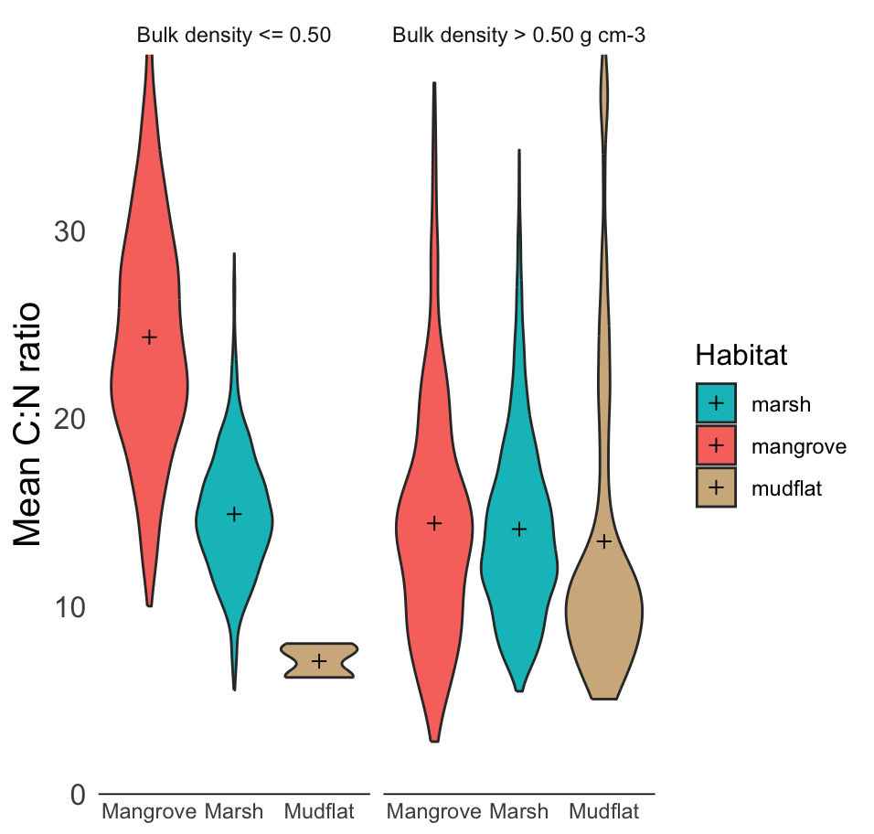

**Fig. S2**. Soil C:N ratio of each habitat type according to bulk density class.

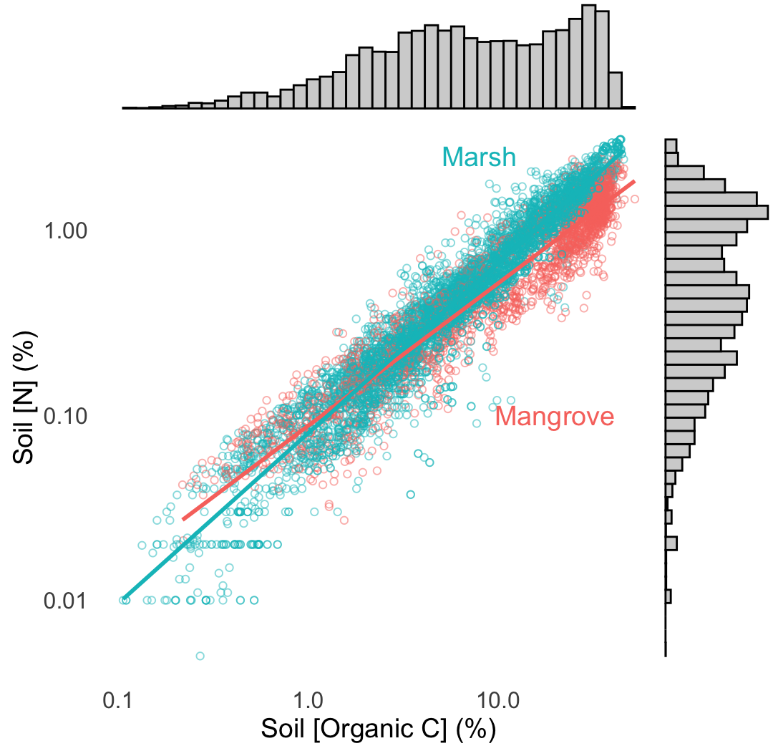

**Fig. S3**. Soil [N] by soil [organic C] plotted on a log axis to better show low-organic matter soils.

**References**

Atwood, T. B., Connolly, R. M., Almahasheer, H., Carnell, P. E., Duarte, C. M., Ewers Lewis, C. J., Irigoien, X., Kelleway, J. J., Lavery, P. S., & Macreadie, P. I. (2017). Global patterns in mangrove soil carbon stocks and losses. *Nature Climate Change*, *7*(7), 523–528.

Breithaupt, J. L., & Steinmuller, H. E. (2022). Refining the Global Estimate of Mangrove Carbon Burial Rates Using Sedimentary and Geomorphic Settings. *Geophysical Research Letters*, *49*(18), e2022GL100177. https://doi.org/10.1029/2022GL100177

Breithaupt, J. L., Steinmuller, H. E., Rovai, A. S., Engelbert, K. M., Smoak, J. M., Chambers, L. G., Radabaugh, K. R., Moyer, R. P., Chappel, A., Vaughn, D. R., Bianchi, T. S., Twilley, R. R., Pagliosa, P., Cifuentes-Jara, M., & Torres, D. (2023). An Improved Framework for Estimating Organic Carbon Content of Mangrove Soils Using loss-on-ignition and Coastal Environmental Setting. *Wetlands*, *43*(6), 57. https://doi.org/10.1007/s13157-023-01698-z

Brewton, R. A., Kreiger, L. B., Tyre, K. N., Baladi, D., Wilking, L. E., Herren, L. W., & Lapointe, B. E. (2022). Septic system–groundwater–surface water couplings in waterfront communities contribute to harmful algal blooms in Southwest Florida. *Science of The Total Environment*, *837*, 155319.

Campbell, A. D., Fatoyinbo, L., Goldberg, L., & Lagomasino, D. (2022). Global hotspots of salt marsh change and carbon emissions. *Nature*, *612*(7941), 701–706.

Cornwell, J. C., Owens, M. S., & Staver, L. W. (2022). Nutrient retention and release in eroding Chesapeake bay tidal wetlands. *JAWRA Journal of the American Water Resources Association*, *58*(6), 940–957.

Craft, C. (2007). Freshwater input structures soil properties, vertical accretion, and nutrient accumulation of Georgia and U.S tidal marshes. *Limnology and Oceanography*, *52*(3), 1220–1230. https://doi.org/10.4319/lo.2007.52.3.1220

Currin, C. A., Joye, S. B., & Paerl, H. W. (1996). Diel Rates of N2-fixation and Denitrification in a TransplantedSpartina alternifloraMarsh: Implications for N-flux Dynamics. *Estuarine, Coastal and Shelf Science*, *42*(5), 597–616.

Gruber, N., & Galloway, J. N. (2008). An Earth-system perspective of the global nitrogen cycle. *Nature*, *451*(7176), 293–296.

Hedges, J. I., & Keil, R. G. (1995). Sedimentary organic matter preservation: An assessment and speculative synthesis. *Marine Chemistry*, *49*(2–3), 81–115.

Hinson, A. L., Feagin, R. A., & Eriksson, M. (2019). Environmental Controls on the Distribution of Tidal Wetland Soil Organic Carbon in the Continental United States. *Global Biogeochemical Cycles*, *33*(11), 1408–1422. https://doi.org/10.1029/2019GB006179

Lane, R. R., Mack, S. K., Day, J. W., DeLaune, R. D., Madison, M. J., & Precht, P. R. (2016). Fate of soil organic carbon during wetland loss. *Wetlands*, *36*, 1167–1181.

Lovelock, C. E., Adame, M. F., Bradley, J., Dittmann, S., Hagger, V., Hickey, S. M., Hutley, L. B., Jones, A., Kelleway, J. J., Lavery, P. S., Macreadie, P. I., Maher, D. T., McGinley, S., McGlashan, A., Perry, S., Mosley, L., Rogers, K., & Sippo, J. Z. (2023). An Australian blue carbon method to estimate climate change mitigation benefits of coastal wetland restoration. *Restoration Ecology*, *31*(7), e13739. https://doi.org/10.1111/rec.13739

Macreadie, P. I., Costa, M. D., Atwood, T. B., Friess, D. A., Kelleway, J. J., Kennedy, H., Lovelock, C. E., Serrano, O., & Duarte, C. M. (2021). Blue carbon as a natural climate solution. *Nature Reviews Earth & Environment*, *2*(12), 826–839.

Mason, R. E., Craine, J. M., Lany, N. K., Jonard, M., Ollinger, S. V., Groffman, P. M., Fulweiler, R. W., Angerer, J., Read, Q. D., & Reich, P. B. (2022). Evidence, causes, and consequences of declining nitrogen availability in terrestrial ecosystems. *Science*, *376*(6590), eabh3767.

Mcowen, C. J., Weatherdon, L. V., Van Bochove, J.-W., Sullivan, E., Blyth, S., Zockler, C., Stanwell-Smith, D., Kingston, N., Martin, C. S., & Spalding, M. (2017). A global map of saltmarshes. *Biodiversity Data Journal*, *5*. https://www.ncbi.nlm.nih.gov/pmc/articles/PMC5515097/

Morris, J. T., Sundareshwar, P. V., Nietch, C. T., Kjerfve, B., & Cahoon, D. R. (2002). Responses of coastal wetlands to rising sea level. *Ecology*, *83*(10), 2869–2877.

Murray, N. J., Worthington, T. A., Bunting, P., Duce, S., Hagger, V., Lovelock, C. E., Lucas, R., Saunders, M. I., Sheaves, M., Spalding, M., Waltham, N. J., & Lyons, M. B. (2022). High-resolution mapping of losses and gains of Earth’s tidal wetlands. *Science*, *376*(6594), 744–749. https://doi.org/10.1126/science.abm9583

Odum, E. P. (1980). The status of three ecosystem-level hypotheses regarding salt marsh estuaries: Tidal subsidy, outwelling, and detritus-based food chains. In *Estuarine perspectives* (pp. 485–495). Elsevier. https://www.sciencedirect.com/science/article/pii/B9780124040601500459

Ouyang, X., & Lee, S. Y. (2020). Improved estimates on global carbon stock and carbon pools in tidal wetlands. *Nature Communications*, *11*(1), 317.

Rogers, K., Kelleway, J. J., Saintilan, N., Megonigal, J. P., Adams, J. B., Holmquist, J. R., Lu, M., Schile-Beers, L., Zawadzki, A., & Mazumder, D. (2019). Wetland carbon storage controlled by millennial-scale variation in relative sea-level rise. *Nature*, *567*(7746), 91–95.

Rovai, A. S., Twilley, R. R., Castañeda-Moya, E., Riul, P., Cifuentes-Jara, M., Manrow-Villalobos, M., Horta, P. A., Simonassi, J. C., Fonseca, A. L., & Pagliosa, P. R. (2018). Global controls on carbon storage in mangrove soils. *Nature Climate Change*, *8*(6), 534–538.

Saintilan, N., Horton, B., Törnqvist, T. E., Ashe, E. L., Khan, N. S., Schuerch, M., Perry, C., Kopp, R. E., Garner, G. G., & Murray, N. (2023). Widespread retreat of coastal habitat is likely at warming levels above 1.5° C. *Nature*, 1–8.

Saintilan, N., Kovalenko, K. E., Guntenspergen, G., Rogers, K., Lynch, J. C., Cahoon, D. R., Lovelock, C. E., Friess, D. A., Ashe, E., Krauss, K. W., Cormier, N., Spencer, T., Adams, J., Raw, J., Ibanez, C., Scarton, F., Temmerman, S., Meire, P., Maris, T., … Khan, N. (2022). Constraints on the adjustment of tidal marshes to accelerating sea level rise. *Science*, *377*(6605), 523–527. https://doi.org/10.1126/science.abo7872

Sapkota, Y., & White, J. R. (2021). Long-term fate of rapidly eroding carbon stock soil profiles in coastal wetlands. *Science of the Total Environment*, *753*, 141913.

Schlesinger, W. H. (2009). On the fate of anthropogenic nitrogen. *Proceedings of the National Academy of Sciences*, *106*(1), 203–208.

Schuerch, M., Spencer, T., Temmerman, S., Kirwan, M. L., Wolff, C., Lincke, D., McOwen, C. J., Pickering, M. D., Reef, R., & Vafeidis, A. T. (2018). Future response of global coastal wetlands to sea-level rise. *Nature*, *561*(7722), 231–234.

Spencer, T., Schuerch, M., Nicholls, R. J., Hinkel, J., Lincke, D., Vafeidis, A. T., Reef, R., McFadden, L., & Brown, S. (2016). Global coastal wetland change under sea-level rise and related stresses: The DIVA Wetland Change Model. *Global and Planetary Change*, *139*, 15–30.

Spivak, A. C., Sanderman, J., Bowen, J. L., Canuel, E. A., & Hopkinson, C. S. (2019). Global-change controls on soil-carbon accumulation and loss in coastal vegetated ecosystems. *Nature Geoscience*, *12*(9), 685–692.

Tang, J., Ye, S., Chen, X., Yang, H., Sun, X., Wang, F., Wen, Q., & Chen, S. (2018). Coastal blue carbon: Concept, study method, and the application to ecological restoration. *Science China Earth Sciences*, *61*, 637–646.

Tobias, C., & Neubauer, S. C. (2019). Salt marsh biogeochemistry—An overview. *Coastal Wetlands*, 539–596.

Twilley, R. R., & Rivera-Monroy, V. H. (2009). Ecogeomorphic models of nutrient biogeochemistry for mangrove wetlands. *Coastal Wetlands: An Integrated Ecosystem Approach*, *1*, 641–684.

Valiela, I., & Teal, J. M. (1979). NITROGEN BUDGET OF A SALT-MARSH ECOSYSTEM. *Nature*, *280*(5724), 652–656. https://doi.org/10.1038/280652a0

Voss, M., Bange, H. W., Dippner, J. W., Middelburg, J. J., Montoya, J. P., & Ward, B. (2013). The marine nitrogen cycle: Recent discoveries, uncertainties and the potential relevance of climate change. *Philosophical Transactions of the Royal Society B: Biological Sciences*, *368*(1621), 20130121. https://doi.org/10.1098/rstb.2013.0121

Wang, F., Sanders, C. J., Santos, I. R., Tang, J., Schuerch, M., Kirwan, M. L., Kopp, R. E., Zhu, K., Li, X., & Yuan, J. (2021). Global blue carbon accumulation in tidal wetlands increases with climate change. *National Science Review*, *8*(9), nwaa296.

Wang, M., Hu, C., Barnes, B. B., Mitchum, G., Lapointe, B., & Montoya, J. P. (2019). The great Atlantic *Sargassum* belt. *Science*, *365*(6448), 83–87. https://doi.org/10.1126/science.aaw7912